Lab 2 – ER Modeling

Name- SIMRAN

Student ID- 100377444

Q1. A company database needs to store information about employees (identified by ssn, with salary and phone as attributes), departments (identified by dno, with dname and budget as attributes), and children of employees (with name and age as attributes). Employees work in departments; each department is managed by an employee; a child must be identified uniquely by name when the parent (who is an employee; assume that only one parent works for the company) is known. We are not interested in information about a child once the parent leaves the company. Draw an ER diagram using CROW’s Foot or UML Notation that captures this information.

ANS: ER diagram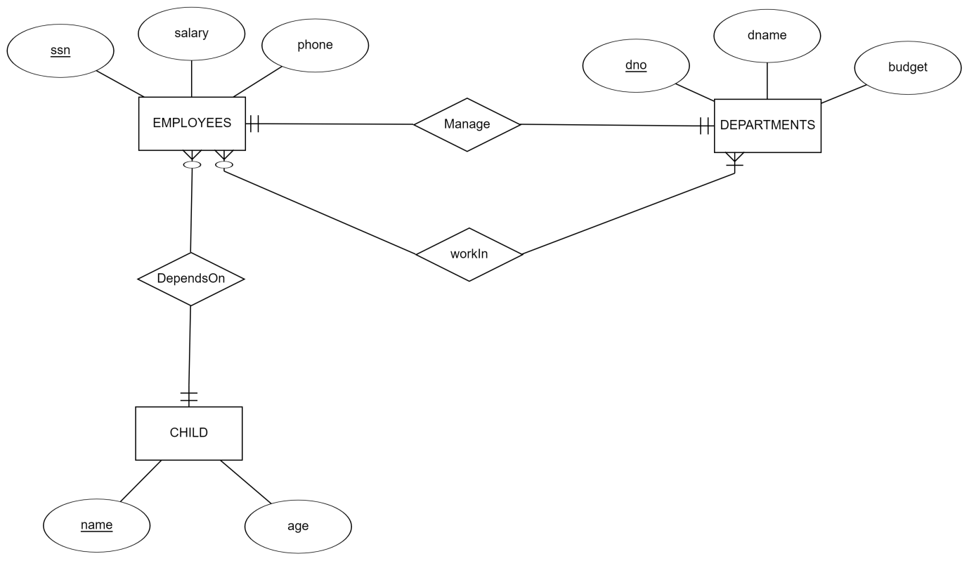

Relational schema:

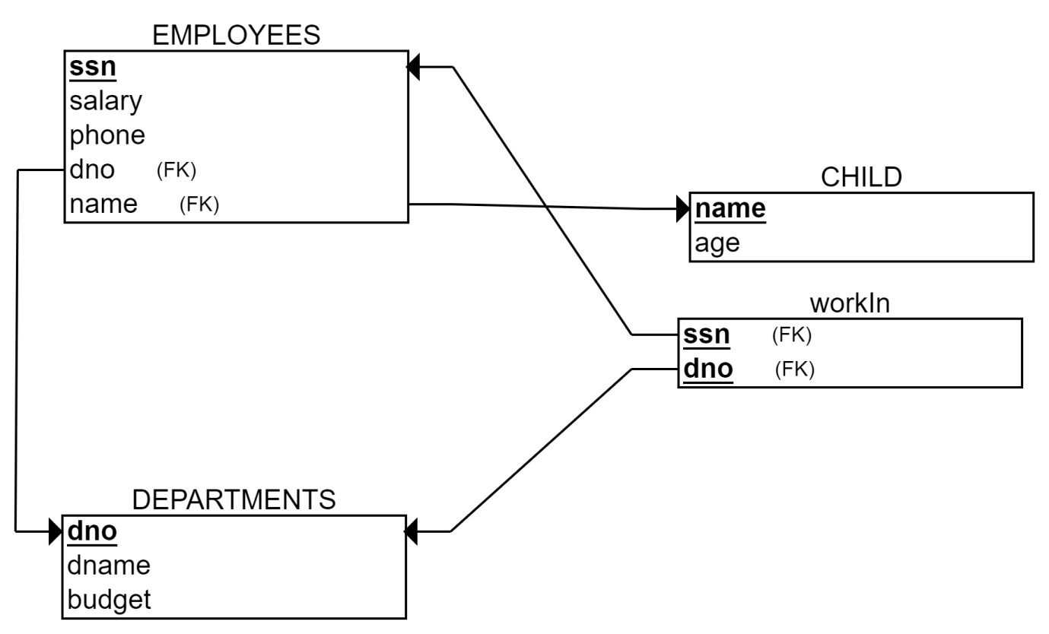

Q2. Consider the ER diagram of online sales system above. Based on the diagram answer the questions below,

1. Based on the ER Diagram, determine the Foreign Key in the Product Table. Just mention the name of the attribute that could be the Foreign Key.

ANS: OrderID is the foreign key in Product Table because it is primary key in the Order table.

1. Mention the relationship between the Order and Customer Entities. You can use the following:

1:1, 1:M, M:1, 0:1, 1:0, M:0, 0:M

ANS: M:1 relationship

1. Is there a direct relationship that exists between Store and Customer entities? Answer Yes/No?

ANS: No

1. Which of the 4 Entities mention in the diagram can have a recursive relationship?

ANS: Customer entity can have recursive relationship.

1. If a new entity Order_Details is introduced, will it be a strong entity or weak entity? If it is a weak entity, then mention its type?

ANS: It is weak entity and associative entity.